


GOVERNMENT ARTS AND SCIENCE COLLEGE
WIMCO NAGAR
THIRUVOTTIYUR ,CHENNAI-19

FITTRACK AI

Team ID: SWTID-2026-7377
Team Size: 4


Team Leader: SURYA S

Team Member: THILOTHAMMA B

Team Member: VANAJA A

Team Member: SHYAM C

AI FitTrack API
FitSense - Personalized fitness recommendations powered by AI.
Description
Built using Node.js, Express.js, MongoDB, and Mongoose, the backend exposes REST APIs that enable secure user authentication, workout management, workout searching, and AI-assisted fitness guidance.
The application follows the Model-View-Controller (MVC) architecture, making the project modular, maintainable, and scalable. User authentication is implemented using JSON Web Tokens (JWT), while passwords are securely encrypted using bcrypt.js before storage in MongoDB.
One of the key features of the project is its integration with Google Gemini AI.
Scenario-Based Case Study
Background
Rahul is a fitness enthusiast who exercises regularly but records his workouts manually using notebooks and spreadsheets. Although he maintains consistency in his fitness routine, he finds it difficult to organize workout history, monitor progress, and determine whether his exercise habits align with his fitness goals.
Problem
- Difficulty maintaining a centralized record of workouts.
- Manual tracking leads to inaccurate workout history.
- No secure user authentication for personal fitness records.
- Unable to search previous workouts efficiently.
- No personalized workout recommendations.
- No insights regarding overall workout performance.
- Time-consuming manual calculation of calories burned and workout duration.

Solution
The FitTrack AI provides a centralized backend system where users can securely register, authenticate, and manage workout records. Users can add, update, delete, retrieve, and search workouts through RESTful APIs. By integrating Google Gemini AI, the application analyzes user information and workout statistics to generate intelligent workout recommendations and personalized fitness insights.
Usage
User Usage
A registered user can create an account using the registration endpoint and securely log in using email and password. After successful authentication, the backend generates a JWT token that authorizes access to protected APIs.
Using authenticated APIs, users can:
- Create new workout records.
- View all previously completed workouts.
- Retrieve a workout by its unique identifier.
- Update existing workout information.
- Delete unwanted workout records.
- Search workouts using workout name, category, or workout date.
- Generate AI-powered workout recommendations.
- Obtain AI-generated fitness insights based on workout statistics.
AI Usage
The AI module communicates with Google Gemini using a dedicated service layer.
Users provide information such as:
- Age
- Fitness Goal
- Experience Level
Gemini processes this information and returns:
- Personalized workout plan
- Weekly exercise suggestions
- Beginner/Intermediate/Advanced recommendations
- Motivational guidance
- Safety tips
Similarly, users can submit workout statistics including:
- Total Workouts
- Average Workout Duration
- Total Calories Burned
The AI module analyzes these values and produces personalized fitness insights.
Outcome
The modular MVC architecture enables easy maintenance and future scalability. The application can later be extended with additional features such as nutrition tracking, BMI calculation, wearable device integration, workout reminders, and fitness analytics dashboards without major architectural changes.

1. Software Requirements
The FitTrack AI requires the following software components for development and execution.Operating System: Windows 10/11, macOS, or Linux (supports cross-platform operations).
- Node.js (v16 or above): Runtime ecosystem running server logic and routing infrastructure.
- npm (v8 or above): Node package manager to control operational dependencies.
- Express.js: Lightweight routing web framework to construct backend RESTful entry points.
- MongoDB: Document NoSQL engine storing users, posts, categories, comments, and analytics metrics.
- Postman: API verification toolkit to assert schema validation responses across administrative route shields.
- Code Editor: Visual Studio Code or similar IDE environment.
2. Hardware Requirements
- Processor: Intel Core i5 (8th Gen or above) / AMD Ryzen 5 or equivalent.
- RAM: 8 GB minimum (16 GB recommended for concurrent instances of MongoDB, processing layers, and execution nodes).
- Storage: 1 GB of available disk workspace.
Epic 1: Project Architecture
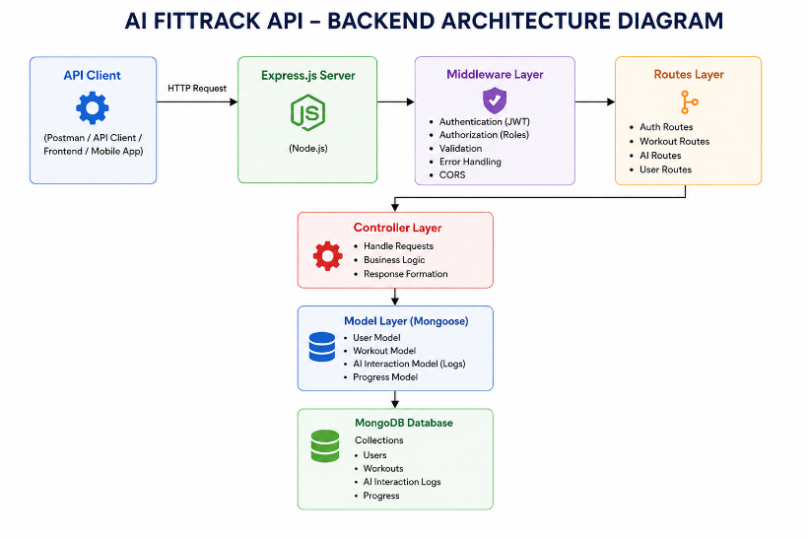
The FitTrack AI follows a layered architecture based on the MVC (Model–View–Controller) design pattern. The application separates routing, business logic, database interaction, middleware, and AI services into independent modules, making the project easier to maintain and scale.
Overall Architecture Components
- Client Application (React / Mobile App / Postman)
- Express Server
- API Routes
- Authentication Middleware
- Controllers
- Services
- Google Gemini AI Service
- MongoDB Database
- Mongoose Models
Components Definition
The FitTrack AI follows a modular backend architecture in which every component performs a dedicated responsibility. The separation of concerns ensures maintainability, scalability, and efficient execution of requests. Each request passes through multiple layers before reaching the database or AI service, ensuring secure and reliable processing.
1. Client Layer (Frontend/API Consumer)
The Client Layer is the entry point of the application. It can be a React application, mobile application, or API testing tool such as Postman. The client sends HTTP requests to the backend server and receives JSON responses.
Responsibilities
- Sends API requests.
- Displays workout information.
- Stores JWT token after login.
- Invokes AI recommendation APIs.
- Displays success and error responses.
APIs Accessed
- Authentication APIs
- Workout APIs
- AI Recommendation APIs
- AI Fitness Insight APIs
2. Express Server Gateway
The Express server acts as the central gateway of the application. It listens for incoming requests, configures middleware, parses request bodies, enables CORS, and routes requests to the appropriate controllers.
Responsibilities
- Starts HTTP server
- Parses JSON requests
- Enables Cross-Origin Resource Sharing (CORS)
- Registers application routes
- Connects middleware
- Handles centralized errors
Example Responsibilities
- Receive HTTP Request
- Validate Request Format
- Forward Request to Routes
- Return JSON Response
3. Authentication Middleware
Authentication middleware protects all secured APIs by validating the JSON Web Token (JWT). Every protected request must include a valid Authorization header.
Responsibilities
- Read Authorization Header
- Extract JWT Token
- Verify JWT Signature
- Decode User Information
- Attach User Information to Request
- Reject Unauthorized Requests
Benefits
- Prevents unauthorized access
- Secures workout information
- Allows only authenticated users to access protected APIs
- Eliminates repeated authentication logic inside controllers
4. Route Layer
Authentication Routes
- Register User
- Login User
- User Profile
Workout Routes
- Add Workout
- Get All Workouts
- Search Workouts
- Get Workout by ID
- Update Workout
- Delete Workout
AI Routes
- Workout Recommendation
- Fitness Insights
5. Controller Layer
Controllers contain the application's business logic. They receive requests from routes, validate input data, invoke services or database operations, and generate standardized JSON responses.
Authentication Controller
Responsible for:
- User Registration
- User Login
- User Profile Retrieval
Workout Controller
Responsible for:
- Creating Workout Records
- Retrieving Workout Records
- Updating Workouts
- Deleting Workouts
- Searching Workouts
AI Controller
Responsible for:
- Sending prompts to Google Gemini
- Receiving AI-generated recommendations
- Returning AI responses to clients
6. Service Layer
The Service Layer contains reusable business logic that can be shared among multiple controllers.
Gemini AI Service
Responsible for:
- Preparing prompts
- Sending prompts to Google Gemini
- Receiving AI-generated responses
- Returning formatted recommendations
JWT Service
Responsible for:
- Creating JWT Tokens
- Configuring Token Expiry
- Verifying User Identity
Password Service
Responsible for:
- Hashing Passwords
- Comparing Passwords During Login
7. Database Layer
MongoDB stores all persistent application data. Mongoose acts as an Object Data Modeling (ODM) library that simplifies communication between Node.js and MongoDB.
Collections
- Users Collection
- Workouts Collection
Advantages
- Flexible Schema
- High Performance
- Easy Data Retrieval
- Scalable Architecture
Entity Relationship (ER) Diagram Description
The AI FitTrack backend consists of two primary collections that are logically connected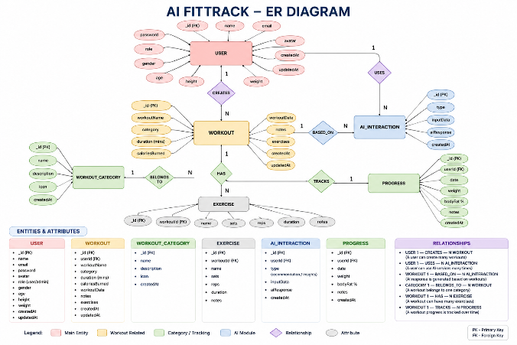
1. User Entity
The User entity stores authentication and profile information.
Attributes
Field | Type | Description
_id | ObjectId | Primary Key
name | String | User Name
email | String | Unique Email Address
password | String | Encrypted Password
createdAt | Date | Record Creation Time
updatedAt | Date | Last Updated Time
Constraints
- Email must be unique.
- Password is encrypted using bcrypt.
- Name is mandatory.
- JWT token is generated after successful login.
2. Workout Entity
The Workout entity stores workout-related information for each authenticated user.
Attributes
Field | Type | Description
_id | ObjectId | Primary Key
user | ObjectId | References User Collection
workoutName | String | Workout Name
category | String | Workout Category
duration | Number | Duration (Minutes)
caloriesBurned | Number | Calories Burned
workoutDate | Date | Workout Date
createdAt | Date | Created Timestamp
Relationship
User → Workout
Relationship Type: One-to-Many
A single user can create multiple workout records. Each workout belongs to only one authenticated user.
Example:
John Doe
- Morning Running
- Evening Jogging
- Upper Body Strength
- Cycling Session
Key Features
The FitTrack AI provides a complete backend solution for workout tracking and AI-assisted fitness guidance.
1. Secure Authentication
The application implements JWT-based authentication.
Features include:
- User Registration
- Secure Login
- Password Encryption
- JWT Generation
- Protected APIs
2. Workout Management
- Add Workout
- View Workout
- Update Workout
- Delete Workout
3. Workout Search
Users can search workouts using:
- Workout Name
- Workout Category
- Workout Date
4. Google Gemini Integration
- Age
- Fitness Goal
- Experience Level
Output
- Weekly Workout Plan
- Suggested Exercises
- Training Tips
- Safety Recommendations
5. AI Fitness Insights
Input
- Total Workouts
- Average Duration
- Calories Burned
Output
- Performance Analysis
- Improvement Suggestions
- Motivational Advice
- Fitness Progress Summary
6. Centralized Error Handling
- Invalid Credentials
- Missing Authentication Token
- Validation Errors
- Database Errors
- Internal Server Errors
7. RESTful API Design
- GET
- POST
- PUT
- DELETE
8. Modular Architecture
- Models
- Controllers
- Routes
- Middleware
- Services
- Configuration
Roles and Responsibilities
The AI FitTrack backend supports one primary role.
Authenticated User
Responsibilities
- Register an account.
- Login securely.
- View profile information.
- Add workout records.
- View workout history.
- Search workouts.
- Update workouts.
- Delete workouts.
- Request AI workout recommendations.
- Request AI fitness insights.
Permissions
Operation | Permission
Register | Yes
Login | Yes
View Profile | Yes
Add Workout | Yes
Get Workouts | Yes
Search Workouts | Yes
Update Workout | Yes
Delete Workout | Yes
AI Recommendation | Yes
Fitness Insights | Yes

User Flow
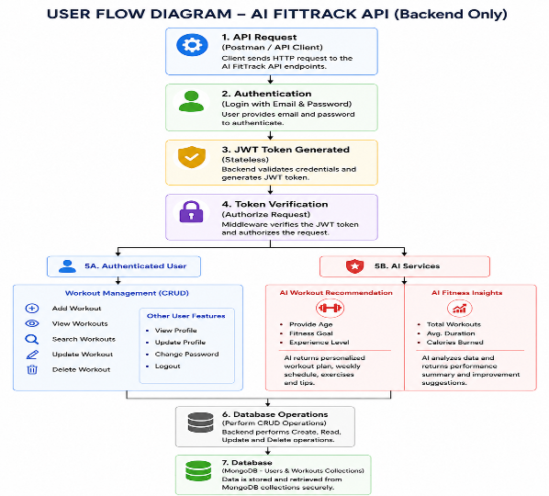
MVC Architecture Pattern
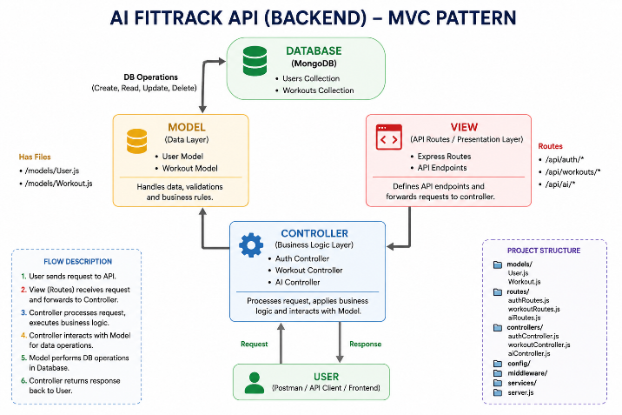

Model Layer (Data Layer)
Models in the project include:
- User Model
- Workout Model
Responsibilities:
- Schema Definition
- Data Validation
- CRUD Operations
- Collection Mapping
View Layer (API Interface)
Responsibilities:
- Send Requests
- Receive JSON Responses
- Display Data
- Handle Client-side Interaction
Controller Layer (Business Logic)
Responsibilities:
- Request Validation
- Business Logic Execution
- Database Interaction
- AI Service Invocation
- Response Generation
Epic 2: Project Setup and Configuration
The backend is developed using Node.js and Express.js, with MongoDB as the primary database and Google Gemini AI for intelligent fitness recommendations.
Creating Project Folder
Step 1: Create the Project Folder
Create a new folder with the project name.
AI-FitTrack-API
Step 2: Open the Project
Open the project folder in Visual Studio Code.
Step 3: Create the Server Folder
Inside the project directory, create a folder named: server
All backend source code will be maintained inside this folder.
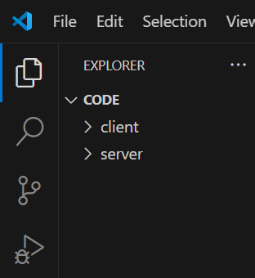
Step 4: Initialize Node Project
Open the terminal inside the server folder and execute:
npm init -y
This command generates the package.json file containing project metadata and dependency information.
Step 5: Install Required Packages
Install the required dependencies.
npm install express mongoose dotenv bcryptjs jsonwebtoken cors
Install Nodemon as a development dependency.
npm install --save-dev nodemon
Environment Variables
Sensitive information is stored in the .env file.
Example
PORT=5000
MONGO_URI=mongodb://localhost:27017/aifittrack
JWT_SECRET=your_secret_key
GEMINI_API_KEY=your_google_gemini_api_key
Using environment variables improves security by preventing sensitive information from being exposed in source code.
Epic 3: Backend Development
Backend development focuses on implementing REST APIs that allow authenticated users to manage workouts and interact with Google Gemini AI.
The project is divided into multiple modules that collectively perform authentication, workout management, AI integration, and database operations.
Major modules include:
- Server Configuration
- Database Configuration
- Authentication
- Workout Management
- AI Recommendation
- Middleware
- Error Handling
Video Link: https://drive.google.com/file/d/1KswrctSaPI0eOYyJ3GkbbVHvHsU3EfZJ/view?usp=sharing
Epic 4: Database Configuration
The FitTrack AI uses MongoDB as its primary NoSQL database for storing user credentials and workout information. Mongoose serves as the Object Data Modeling (ODM) library, enabling seamless interaction between the application and the MongoDB database. Mongoose provides schema validation, middleware support, data relationships, and simplified CRUD operations.
MongoDB Configuration
MongoDB stores application data in collections rather than traditional relational database tables. The FitTrack AI maintains separate collections for users and workouts.
Database Collections
- Users Collection
- Workouts Collection
Installing Mongoose
Install Mongoose using npm.
npm install mongoose
Mongoose acts as the bridge between the Node.js application and MongoDB by providing schema definitions, validation, and database methods.
MongoDB Connection
The database connection is configured inside the config/db.js file. This module establishes a connection to the MongoDB server when the application starts.
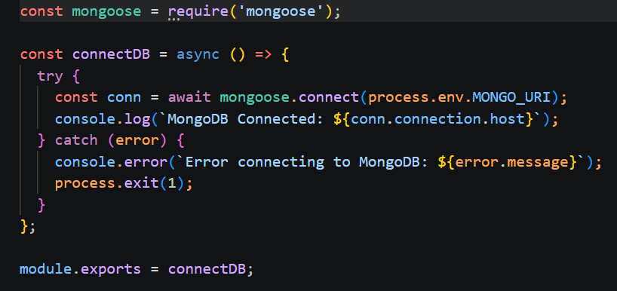
Responsibilities
- Connect to MongoDB
- Handle Connection Errors
- Display Connection Status
- Export Database Connection
Advantages
- Centralized database configuration
- Reusable connection module
- Automatic connection management
- Simplified error handling
Mongoose Schemas
- User Schema
- Workout Schema

1. User Schema (models/User.js)
The User schema stores authentication information for registered users.
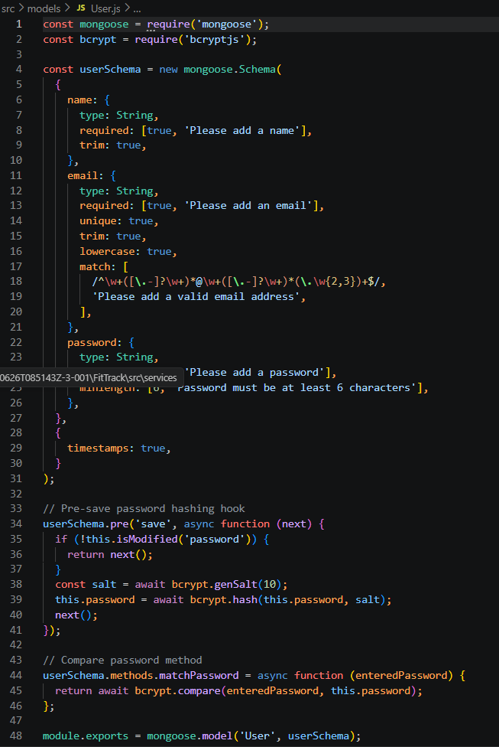
Validation Rules
- Name cannot be empty.
- Email must be unique.
- Password is mandatory.
- Password is encrypted using bcrypt.js before saving.
- Automatic timestamps are enabled.
User Schema Features
- Email uniqueness validation
- Password hashing
- Automatic timestamps
- Secure authentication support
- JWT integration
2. Workout Schema (models/Workout.js)
The Workout schema stores workout information created by authenticated users.
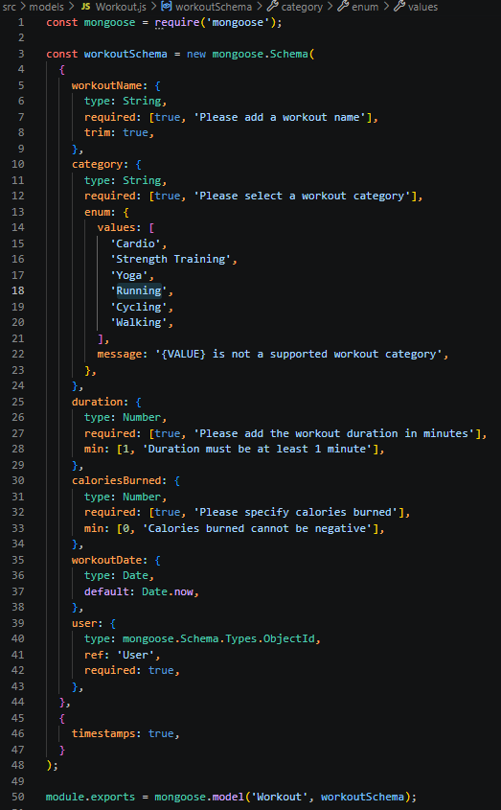
Validation Rules
- Workout Name is mandatory.
- Category is mandatory.
- Duration must be greater than zero.
- Calories Burned must be greater than or equal to zero.
- Workout Date is required.
- Every workout belongs to one authenticated user.
Workout Schema Features
- Schema validation
- Automatic timestamps
- User relationship
- Easy search support
- Efficient CRUD operation
Epic 5: Project Execution
· Install Postman or ThunderClient (VS Code extension).
· Start the backend server:
“npm start”

API Testing
- Authentication APIs
- Workout APIs
- AI APIs
Authentication API Testing
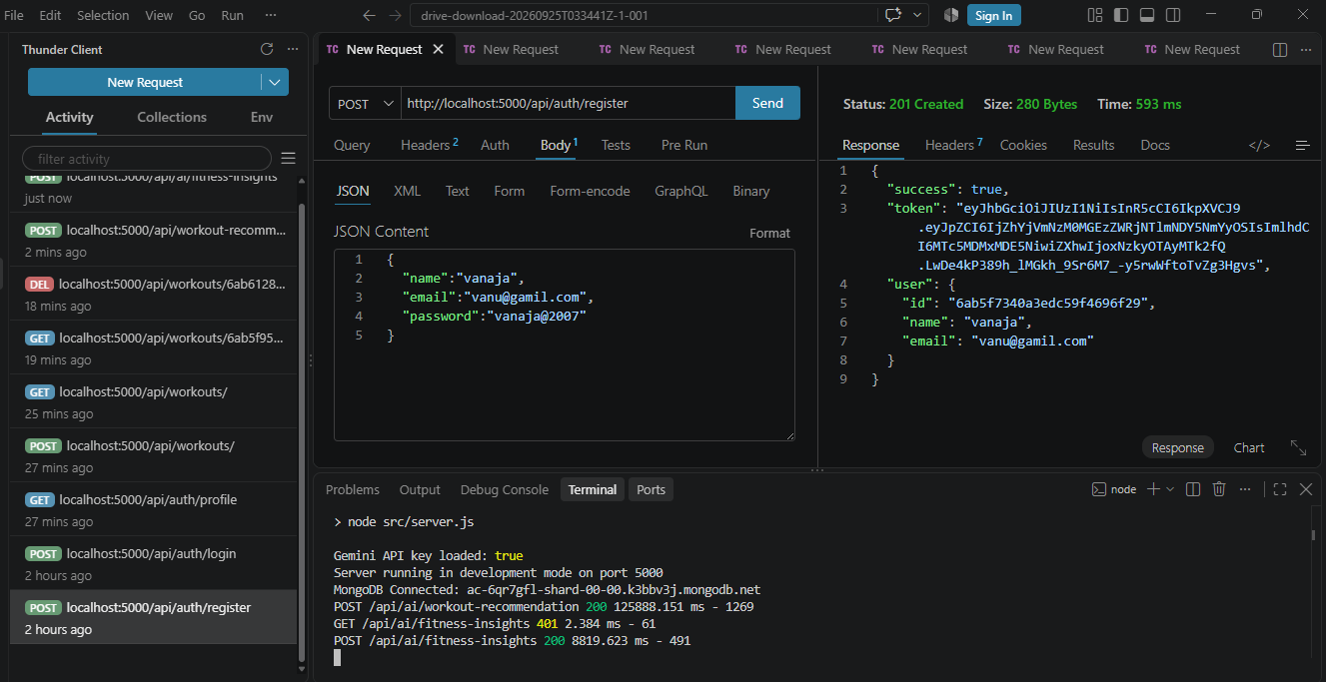

Login User
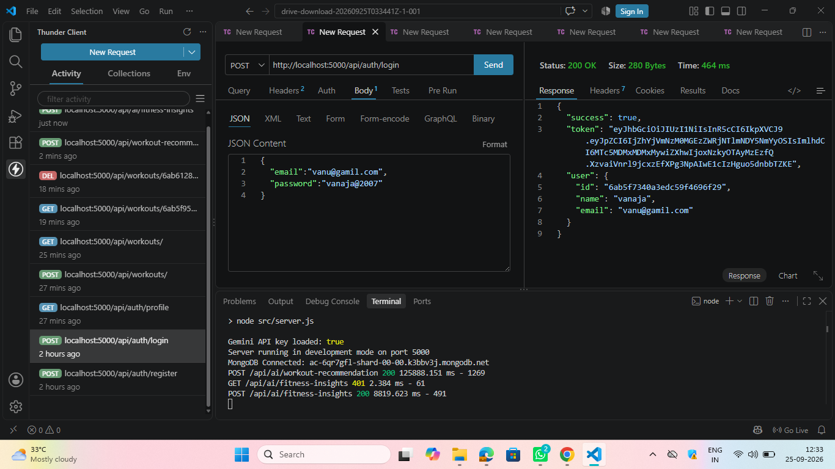

Get Profile
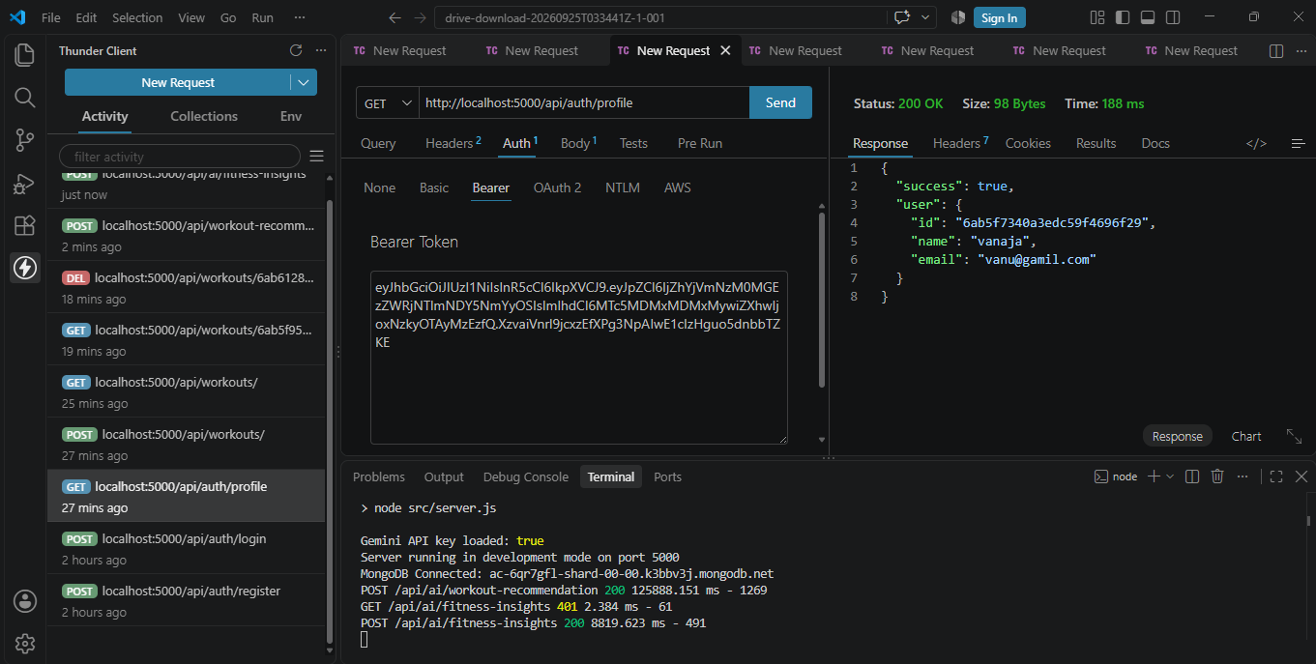
Workout API Testing
Add Workout
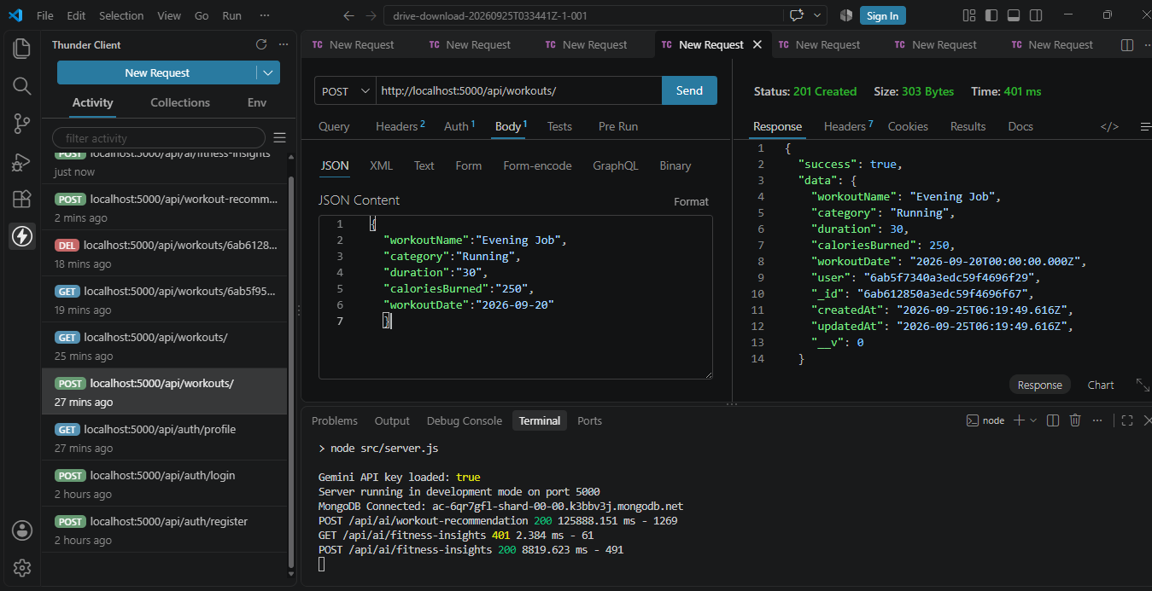

Get All Workouts
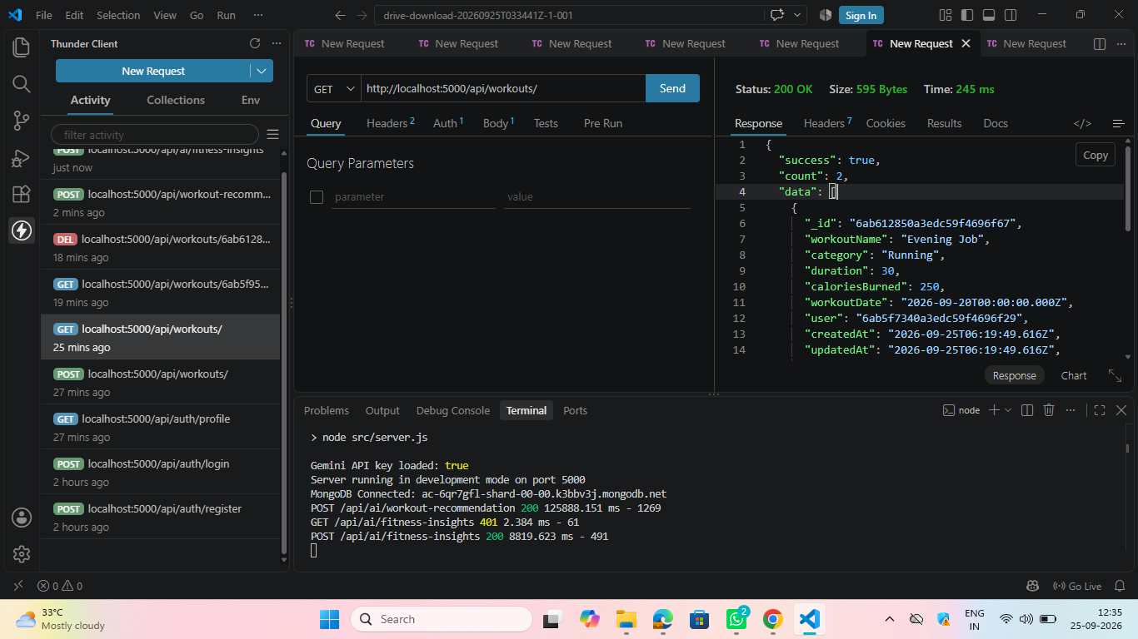

Get Workout By ID

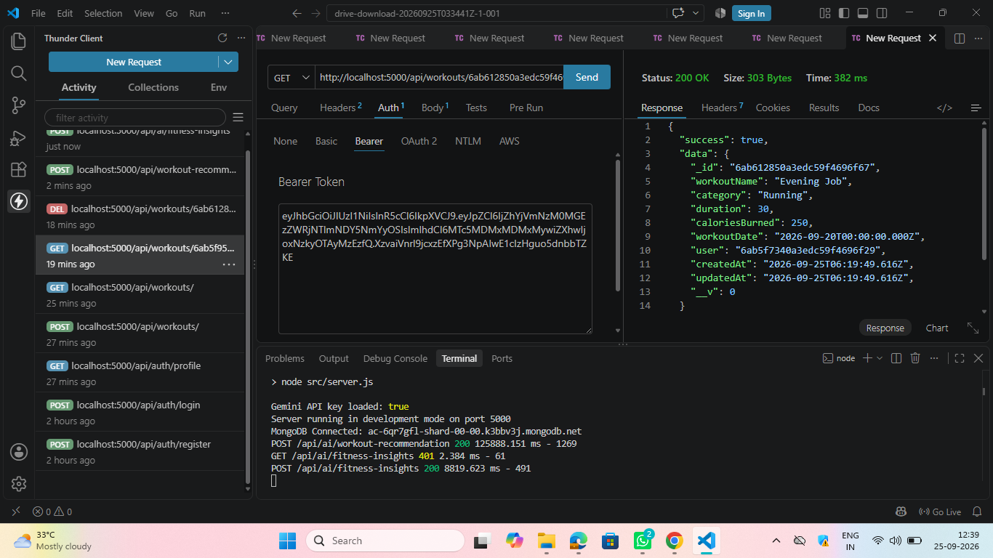

Update Workout

Delete Workout

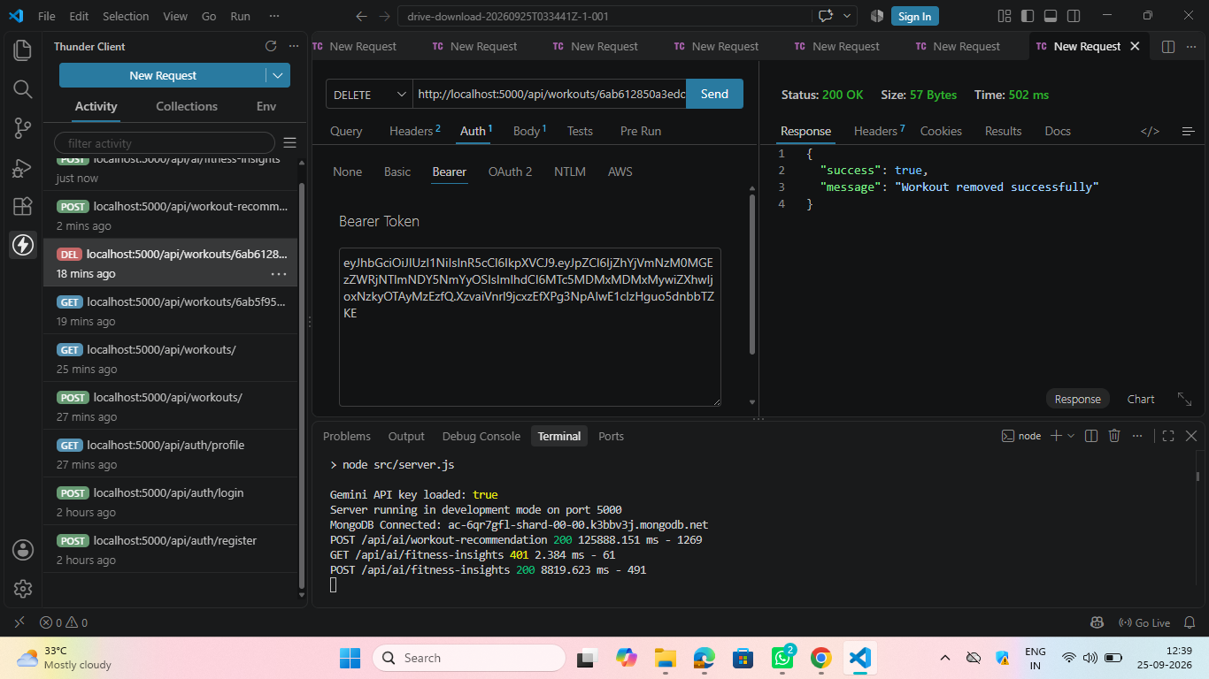

AI API Testing
Workout Recommendation
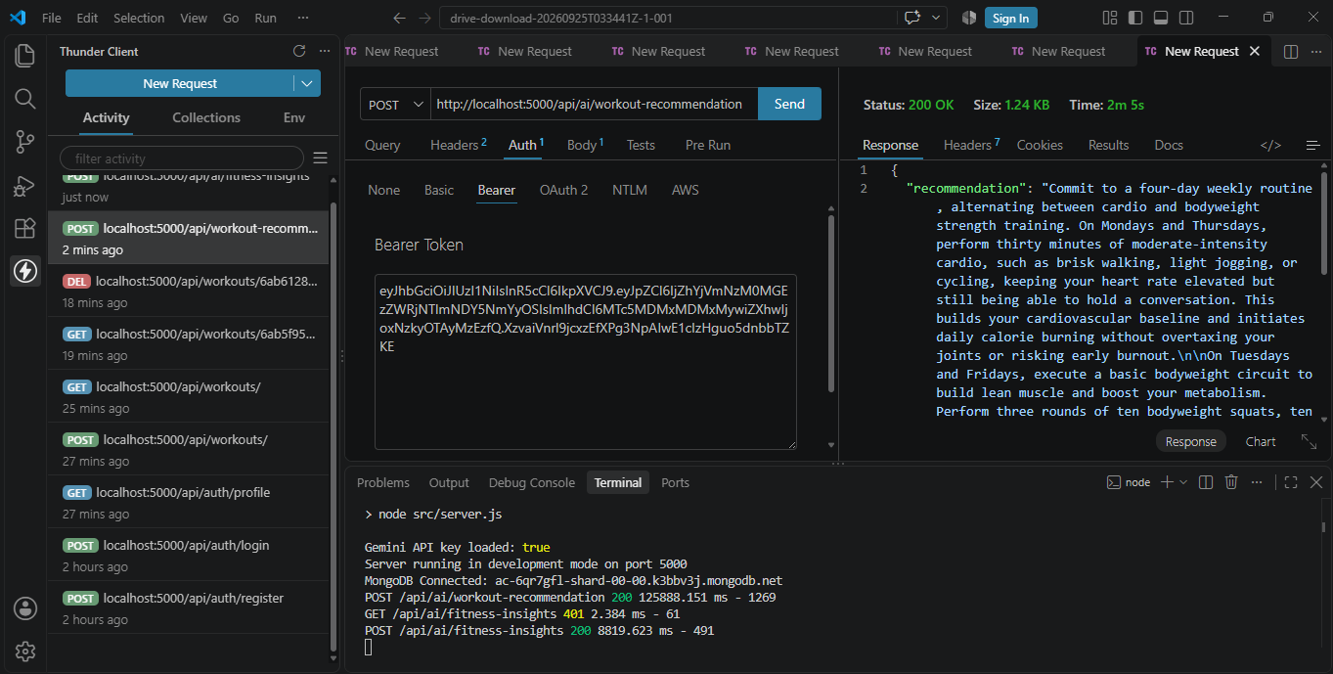
Fitness Insights
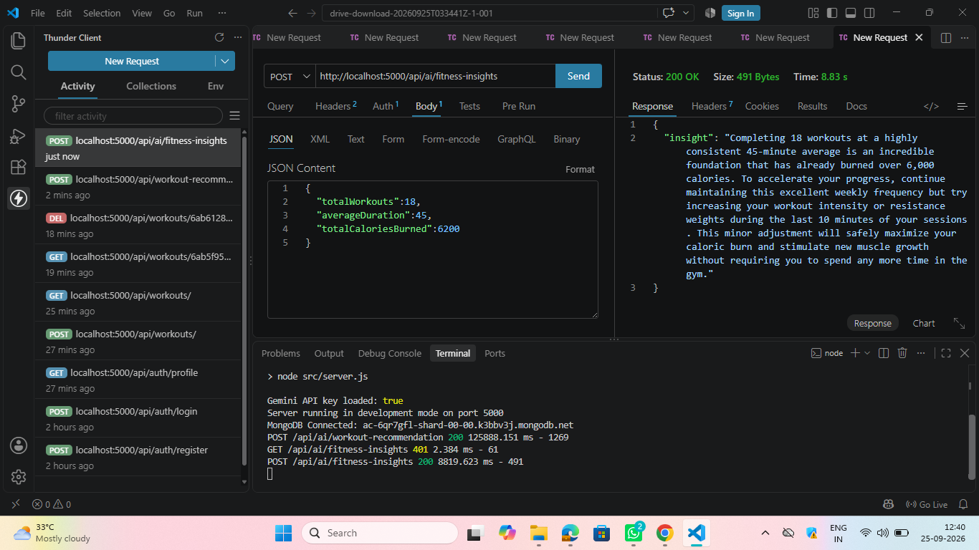

Demo Video Link: https://drive.google.com/file/d/1_4uz_W5lNE2pATzCbTfGvpvWKvZTkxj6/view?usp=drivesdk

THANK YOU

